FLEX-5000 Troubleshooting Guide

Updated on: 22-February-2008

Below are some resolutions to common problems you may encounter during the initial setup and operation of the FLEX-5000A. For a more comprehensive collection of trouble shooting techniques and frequently asked questions (FAQs), please review the information in the FlexRadio Knowledge Base. If you can not find a resolution to your problem from the KB, contact FlexRadio Support at the phone number or e-mail address below.

FLEX-5000 Troubleshooting KB folder
http://kb.flex-radio.com/?cNode=7A0T5M&pNodes=7L5N4B

FLEX-5000 Frequently Asked Questions (FAQ) KB folder
http://kb.flex-radio.com/?cNode=3X5I6U&pNodes=7A0T5M:7L5N4B

Technical Support Contact Information:
+1 (512) 250-8595 -or- support@flex-radio.com

Trouble Condition or Error: “Hardware Not Found” error

If you receive a Hardware Not Found error, indicated by the screen below, it is the result of PowerSDR not being able to communicate with the FLEX-5000

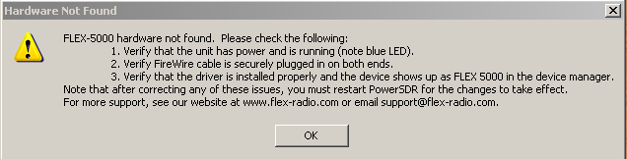

Possible Causes and Resolutions:

- The FLEX-5000 is not powered up (turned on)
- The Firewire cable is not connected to either the FLEX-5000 or the computer
- The FLEX-5000 device driver is not installed correctly
- Malfunctioning Firewire host controller

Trouble Condition or Error: “FLEX-5000 Not Found: Switch to Demo mode?” error is displayed, but the FLEX-5000 Firewire Control Panel recognizes the FLEX-5000 as being attached.

The screen below shows a “FLEX-5000 Not Found: Switch to Demo mode?” error but the FlexRadio FLEX-5000 Control Panel is properly communicating with the FLEX-5000.

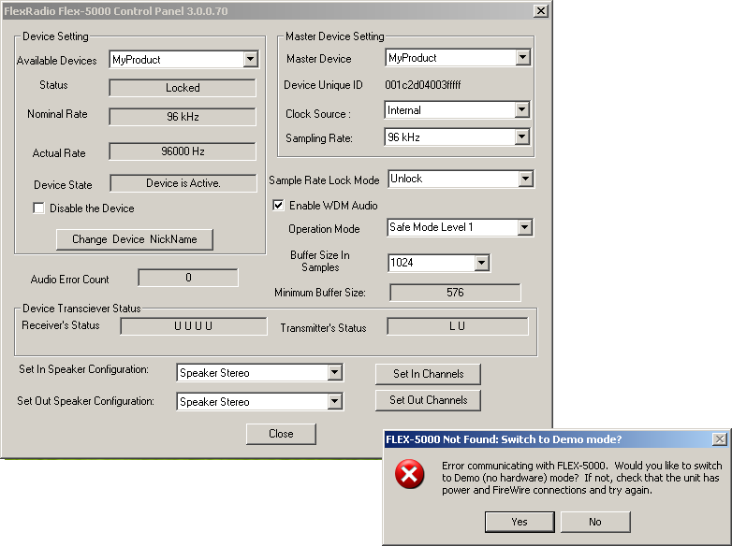

Possible Causes and Resolutions:

- The FLEX-5000 MIDI driver did not register or is not installed correctly. Remove the FLEX-5000 Firewire device driver, reboot and reinstall the FLEX-5000 Firewire device driver. Verify that the FLEX-5000 MIDI device driver is registered with Windows. (see below)
- The FLEX-5000 is not powered up (turned on)
- The Firewire cable is not connected to either the FLEX-5000 or the computer

To verify the FLEX-5000 MIDI driver is properly installed execute the following procedure.

- Open the Windows Control Panel
- Double left click on the Sounds and Audio Devices Control Panel applet
- Left click on the Audio tab
- Left click on the MIDI music playback, default device drop down box.
- Verify that the FlexRadio Flex-5000 is an option. If the FLEX-5000 is the only MIDI device on your computer, select it as the default device. The screen below shows an improperly installed FLEX-5000 MIDI device (FLEX-5000 MIDI device not is shown).

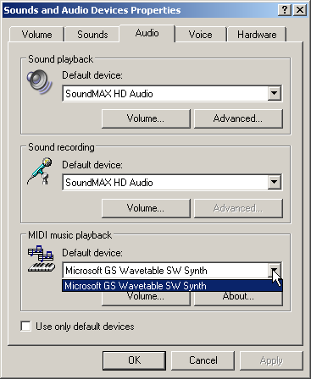

The screen below shows a properly installed FLEX-5000 MIDI device.

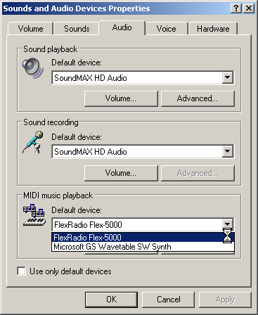

Trouble Condition or Error: No Audio can be heard but there appear to be signals on the Panadapter

Possible Causes and Resolutions:

- The FLEX-5000 mixer is not set to the correct output
- Your powered speakers are malfunctioning or not powered on
- The 1/8” TRS plug has become disconnected from the FLEX-5000 Powered Speaker Output or is not plugged in completely.
- The MUT (mute) button is engaged on the PowerSDR console
- An incorrect receive antenna connector has been selected for that band which has either no antenna connected to it or one that is not resonant for the band selected.
- If using the RX loop feature, the device in-line is turned off or malfunctioning.
- The AF Gain or AGC-T Control on the front panel is set too low.
- Mono (TS) headphones are being used. Use only stereo headphones.

Trouble Condition or Error: No transmit audio. No transmit audio seen on the Panadapter.

Possible Causes and Resolutions:

- The FLEX-5000 mixer is not set to the correct input
- Faulty microphone wiring or incorrect wiring of the MIC or BAL LINE IN connector
- Mic gain set too low
- Using a DIGIx operating mode rather than SSB, AM of FM

Trouble Condition or Error: Receiving High SWR Warnings during transmit

Possible Causes and Resolutions:

- The antenna you are using has an SWR in excess of 3.0:1 on the band selected
- You have the incorrect transmit antenna connector selected for all bands (Antenna Selection Simple mode)
- You have the incorrect transmit antenna connector selected for the band you are on (Antenna Selection Expert mode)
- Faulty coax or connector
- Water in coax or connector
- Antenna is disconnected from the coax
- Trying to operate 6m on an antenna other than ANT3
- Coax disconnected from the FLEX-5000

Trouble Condition or Error: Popping audio heard in the headphones or very low output audio using the Powered Speaker jack

Possible Causes and Resolutions:

- Mono headphones are plugged into the head connector. Stereo headphones are required.
- Powered speaker 1/8 TRS plug in not fully inserted into the powered speakers connector

Trouble Condition or Error: FLEX-5000 Power Indicator LED does not light up after pressing the power switch

Possible Causes and Resolutions:

- The 13.8 VDC power supply is not turned on
- Broken or loose power cable
- Power connector is not completely plugged in
- Blown fuse (internal)
- Blown fuse (external, if applicable)

Trouble Condition or Error: Garbled, raspy or choppy transmit audio on CW and SSB

Possible Causes and Resolutions:

- Operating Mode in the FLEX-5000 device driver Control Panel is set too aggressively. Use Safe Mode 1 or Safe Mode 2
- The sampling rate and buffer size in the FLEX-5000 device driver Control Panel is not the same as the PowerSDR Audio setup.
- Audio buffer is too small for the sampling rate
- Loose Firewire connection

Trouble Condition or Error: Low RF Power Output

Possible Causes and Resolutions:

- Low DC voltage. The minimum voltage required by the FLEX-5000 is 13.25 VDC (Recommend 13.8 VDC @ 35 amps peak / 25 amps continuous).
- Database integrity problems – Allow PowerSDR to create a new database (not a database import)
- The FLEX-5000 requires recalibration of the PA – Contact FlexRadio Support for instructions on how to perform this procedure.

Trouble Condition or Error: Strange Unexpected Behaviors

Possible Causes and Resolutions:

- Database integrity problems – Allow PowerSDR to create a new database (not a database import)
- PowerSDR corruption. Reinstall PowerSDR
- Using an alpha version of PowerSDR. If you are experiencing strange behavior and you are using an alpha version (aka a SVN version), use the latest released version of PowerSDR rather than an alpha version.
- The moon is full <grin>

Trouble Condition or Error: Receiver “goes deaf” when transitioning from transmit to receive and the Panadapter shows a flat signal below -140 dB.

Possible Causes and Resolutions:

- The most current version of the FLEX-5000 firmware is not installed.

Trouble Condition or Error: PowerSDR “freezes” periodically. Pressing the STOP and START button restarts PowerSDR, but after awhile it “freezes” again.

Possible Causes and Resolutions:

- Database integrity problems – Allow PowerSDR to create a new database (not a database import
- Excessive long duration DPCs (deferred procedure calls). Run the DPC Latency checker to verify that you are experiencing long duration DPCs. Any DPCs that are in excess of 1000uS is excessive. (http://www.thesycon.de/deu/latency_check.shtml)
- Operating Mode in the FLEX-5000 device driver Control Panel is set too aggressively. Use Safe Mode 1 or Safe Mode 2
- Multiple Firewire adapters enabled on your computer. If you installed a Firewire host controller in one of your PC’s bus slots and you also have a Firewire host controller on the motherboard, disable the on-board Firewire controller using Windows Device Manager.
- CPU utilization is too high.
- Running other programs at the same time as PowerSDR which are responsible for using hardware in such a manner that it results in long duration DPCs. MS Outlook and Media Player are just some programs known to cause this condition.
- PowerSDR audio buffers and the FLEX-5000 hardware buffers are not the same.
- PowerSDR audio and/or Firewire hardware buffers are set too low for the sampling rate. Increase buffer size or lower the sampling rate.

Trouble Condition or Error: Excessive long duration DPCs (deferred procedure calls).

Possible Causes and Resolutions:

- Out of date or poorly written hardware drivers. Update all of the hardware device drivers on your computer including the motherboard chipset, video and audio drivers.
- Using a motherboard integrated Firewire host controller. Even though some motherboard manufacturers are starting to use quality Firewire chipsets, the implementation in conjunction with other peripherals integrated on the motherboard significantly degrade its performance to unacceptable levels. Using a bus installed (PCI or PCIe) Firewire host controller is recommended.
- Too many hardware devices sharing the same IRQ (interrupt request level) as the Firewire host controller. See KB article Q10422 – Firewire Host Controller Optimizations for Windows XP for more information on how to determine if your Firewire host controller is sharing an IRQ with other hardware.
(http://kb.flex-radio.com/article.aspx?id=10422)

